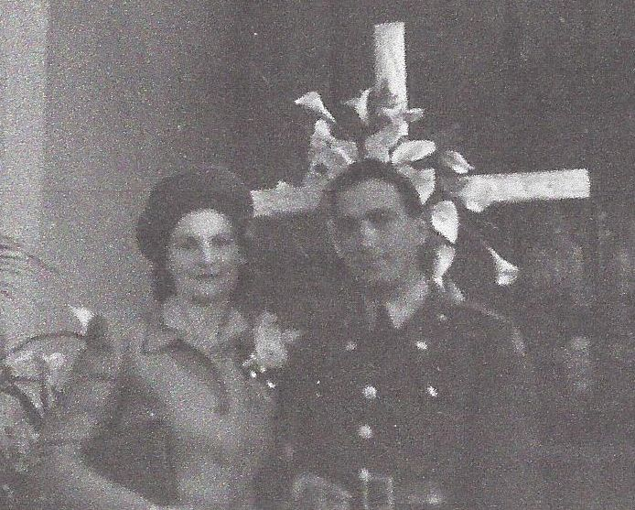

**Josephine Ann Wolfe and newly-wed husband,**

**George J. Fischer – 29 March 1942**

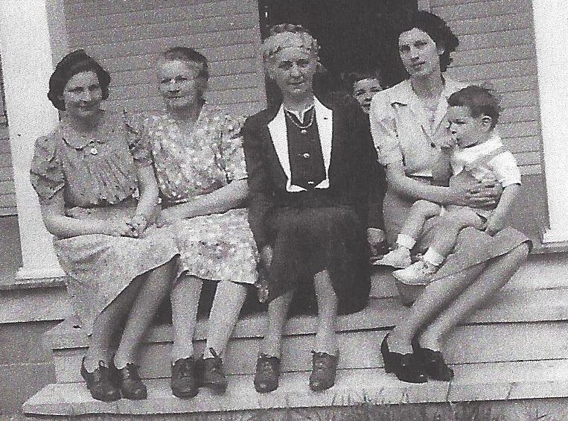

**Josephine Ann Wolfe and mother, Josephine Sybil Worthen Wolfe**

**Anna L. Worthen, Cecile Worthen with sons Tommy & David**

**Photo taken 1942 or 1943**